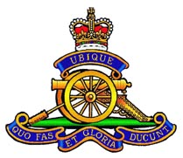
The President and Members of
The Ottawa Gunners
cordially invite
all fellow Gunners, serving or retired,
their spouses
and
friends of the Gunners
to a
St. Barbara’s Mixed Reception
on Sunday, 30 November 2014
from 1300 hrs to 1600 hrs
at
The Army Officers’ Mess, 149 Somerset Ave, Ottawa, ON

Dress Code - #3
Cost - $20.00 per person
Follow us on line at www.ottawagunners.ca and/or https://www.facebook.com/ottawagunners
RSVP – LeonJ1@hotmail.com

