|  |  |  |
| --- | --- | --- |
|  |  |  |
| Fields of Fire Tours in association with The Royal Canadian Artillery Association & The Canadian Battlefields Foundation  presents | | |
| Battlefields of the  Royal Canadian Artillery  17 April – 3 May 2015 | | |

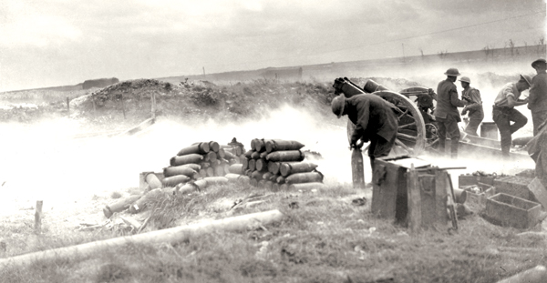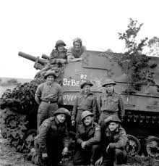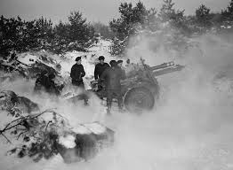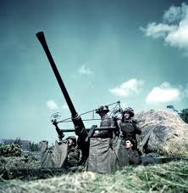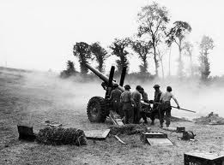

|  |  |  |  |
| --- | --- | --- | --- |
| |  |  | | --- | --- | | • Visit battlefields of the First and Second World Wars  • Follow the path of the Canadian Gunners and visit important battlefields in the development of gunnery in both wars | • Led by experienced military personnel and academic historians  • Visit monuments and Commonwealth War Cemeteries  • small (12-18 members) group ensures personalized service | | • Led by experienced military personnel and academic historians  • Visit monuments and Commonwealth War Cemeteries  • Attend the McCrae Statue unveiling in Ottawa as final event (optional) |
| |  | | --- | | For more information contact Fields of Fire Tours  at [info@foftours.com](mailto:info@foftours.com), or call 613-539-4660 | | |

|  |  |  |  |  |  |
| --- | --- | --- | --- | --- | --- |
| Battlefields of the Royal Canadian Artillery: Tour Itinerary | | | | | |
| Day 1 – 17 April …Depart Canada for Paris.  Day 2 – 18 April …We arrive in Paris, collect our vans and then drive to Ypres. After settling in we will visit the Cloth Hall Museum and Essex Farm cemetery.. Our hotel in Ypres is the **Hotel O.**  Day 3 – 19 April … Today’s tour will examine two important gunner battles: 2nd Ypres and the St Julian gun; and Passchendaele. We will participate in the Menin Gate ceremony, laying a wreath on behalf of the RCA.  Day 4 – 20 April … Departing Ypres we will head for the Somme where the artillery technology of the day was not up to challenge of trench warfare and mass attacks. We will stay in Arras at the **Holiday Inn Express**.  Day 5 – 21 April.... Our schedule today will allow us to examine the Battle for Vimy Ridge in detail. We will look at the abortive French attempts to seize the ridge from the impressive Notre Dame de Lorette cemetery. We will also take a detailed look at each of the four Canadian division’s goals that historic day and the fireplans that supported them.  . | | Day 6 – 22 April … Today’s battlefield will be that of the 1918 battles in front of Arras. The return to mobile warfare will be examined as we look at the battle for the D-Q line and the Canal du Nord  Day 7 – 23 April … Today we will tour the battlefield of Valenciennes, the acme of gunner skill and professionalism in the Great War. Also we will our First War stage where the war began and ended – Mons in Belgium  Day 8 – 24 April … We will head for Normandy next. Our day’s driving will take us past Dieppe where we will stop to look at the infamous beach and the gunner’s role in the battle. Arriving in Caen, our hotel will be the **Hotel de France**.  Day 9 – 25 April … Juno beach and fire support provided by the SP guns of the 3rd Division will be today’s main event. We will visit the gunner memorials at the Juno beach centre and Beny-sur-Mer cemetery where many brave gunners lie at peace.  Day 10 – 26 April … The massive two-week struggle for Verrières Ridge will be our subject today as we move south of Caen.  Day 11 - 27 April … A break from Canadian subjects, but a must-see is the US Omaha beach and the impressive cemetery there. | | Day 12 - 28 April … Another travel day as we make an early drive to Paris to catch the Eurostar train to London, UK. Our hotel will be the **Travelodge Woolwich**.  Day 13 – 29 April … Today we will tour the impressive Firepower museum that chronicles the history of our sister regiment the Royal Artillery.  Day 14 – 30 April.... Travelling into London by tube, we will tour the Imperial War Museum and then have an afternoon to explore this amazing city  Day 15 – 1 May... For those not attending the McCrae ceremony in Ottawa, today will be your travel home day. Those staying with the group will travel to Ottawa, where we will stay at the **Novotel Hotel**  Day 16 – 2 May... In the morning we will visit Canada’s National War Museum, and in the evening attend the dinner honouring Lt-Col John McRae  Day 17 – 3 May... We will attend the unveiling of the McCrae statue and then depart for home from Ottawa. | |
|  | **Land Only** Tour Price from Toronto CAD $4500 – (per person, Double occupancy) (single supplement: $700 – limited availability)  Not returning via Ottawa: CAD $4000 | | | |  |
| Price includes:  ⚫ breakfast daily ⚫ all travel by 9 passenger van ⚫ local sightseeing ⚫ accommodation as shown in the itinerary ⚫services of historian/guides: | | | ⚫ related materials including articles, maps and air photographs  Not Included: ⚫ airfare ⚫ travel insurance ⚫ lunches and dinners | ⚫ items of a personal nature such as beverages ⚫ admissions to museums and other attractions.  Note: limited single room availability – “first come, first served” | |